Year One Online Video Lessons
Please see some information about the online videos below. Please note, we will not be doing all of the videos in the order listed on the websites as some lessons may not be relevant therefore, please ignore the dates on website and use the link/date I set on the Rainbow Challenges instead.
Maths – White Rose
The White Rose Maths Team has prepared a series of maths lessons for each year group. Every lesson comes with a short video showing the children clearly and simply how to help complete the activity successfully. You are then able to download the activity and answer sheets.
We are going to be working a week behind so we will be starting on ‘Summer Term – Week 1 WC 20th April’. I will provide a link every day on the Rainbow Challenge sheet and direct you to the correct lesson.
These lessons are really easy to access and can be done in 3 simple steps. I have provided screenshots below for Monday’s lesson for reassurance.
Step 1: Click on the link provided on the Rainbow Challenge Sheet: (https://whiterosemaths.com/homelearning/year-1/)
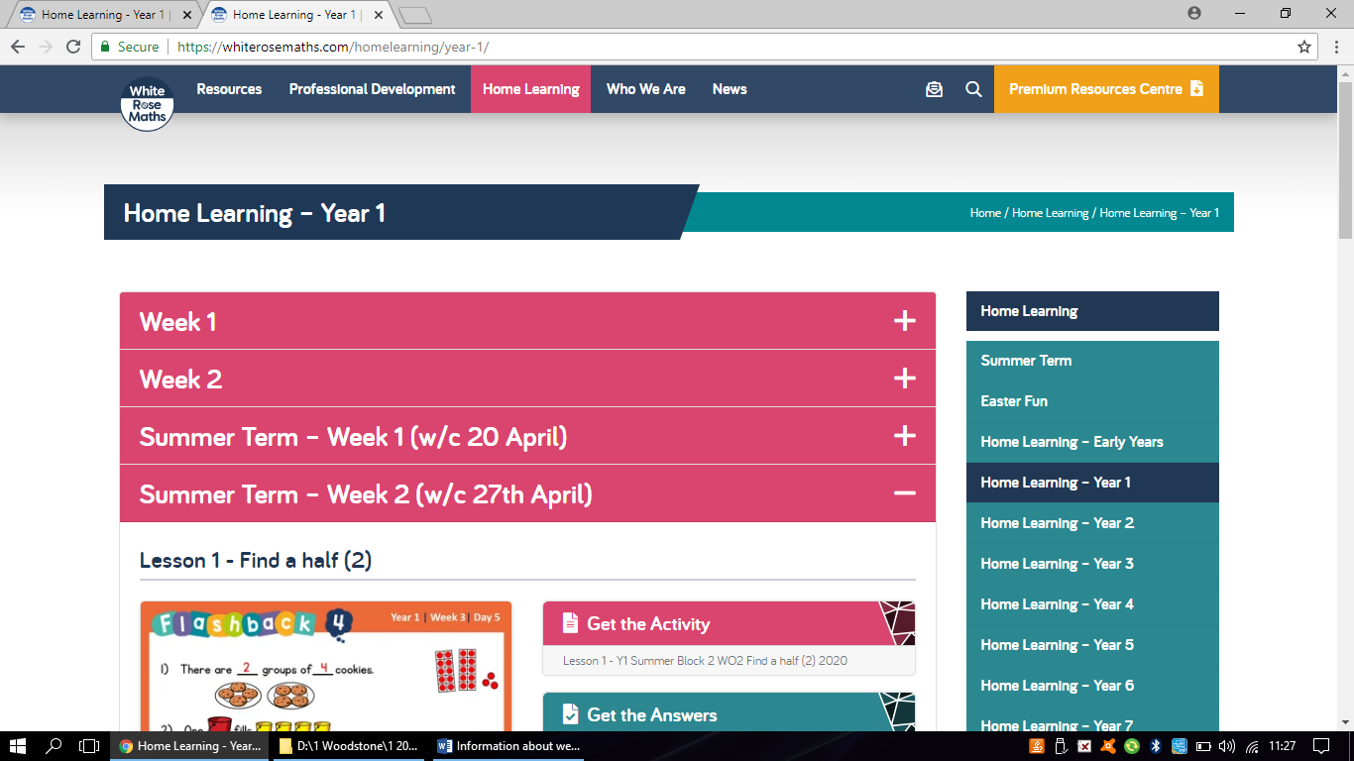

Step 2: Click on ‘Summer Term – Week 1 w/c 20 April’.
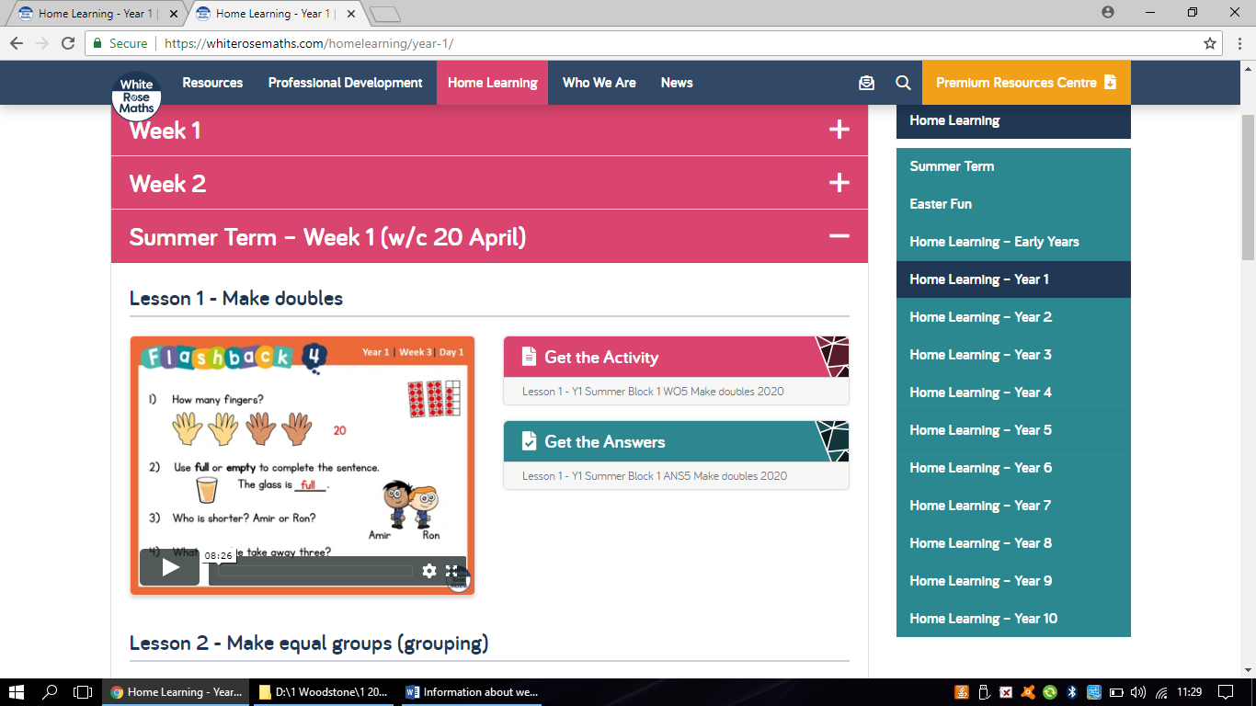

Step 3: Press Play to watch the Video (which can be enlarged) under ‘lesson 1 – Make Doubles’. Then click on ‘Get the Activity to download the pdf activity sheets. You can also download the answers which are displayed below the activity sheets.
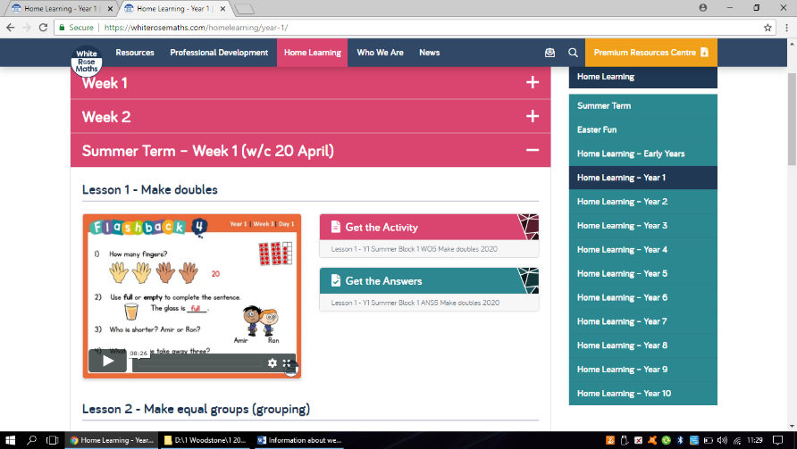

The children would benefit most having the activity sheets printed for them, however, if you do not have access to a printer, please record the answers in their exercise book. Another option would be to copy the questions onto a separate piece of paper for the children to complete. Please accept verbal answers for the questions asked throughout the video or again, children could record their answers in their exercise books if they wish.
English – BBC Bitesize
BBC Bitesize are also providing daily lessons for children in year groups 1-10. Most of the English Challenges on the Rainbow Challenge will direct you to one of these lessons, along with some of the topic/wider curriculum challenges. As mentioned above, these lessons will not be in order as I will be selecting lessons which I feel the children would most benefit from based on what we have already done in school. Every lesson includes a number of activities, please see the daily Rainbow Challenge sheet to be directed to the correct lesson and activity. Most of the activities linked to these lessons do not require any printing and can be completed in the children’s exercise books or a separate piece of paper.
Please see the screenshots below for how to access the Bitesize lesson for Monday’s English Challenge.
Step 1: Click on the link provided on the Rainbow Challenge.
(https://www.bbc.co.uk/bitesize/articles/zd372sg)
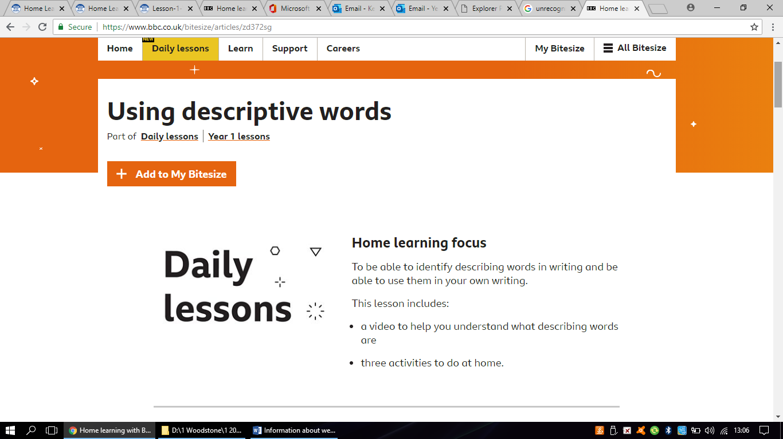

Step 2: Scroll down to find the video lesson and click play to watch the short video (this can be enlarged).
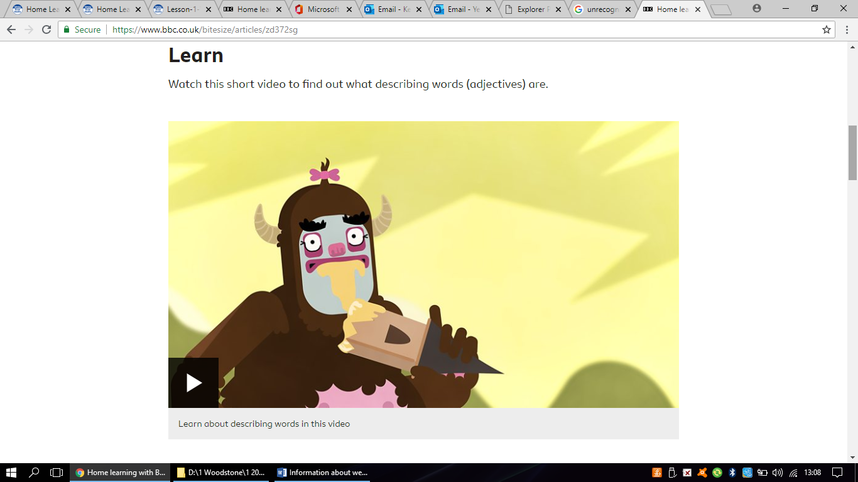
Step 3: Select the activity I have directed you to on the Rainbow Challenge (for Monday’s lesson this will be Activity 1)

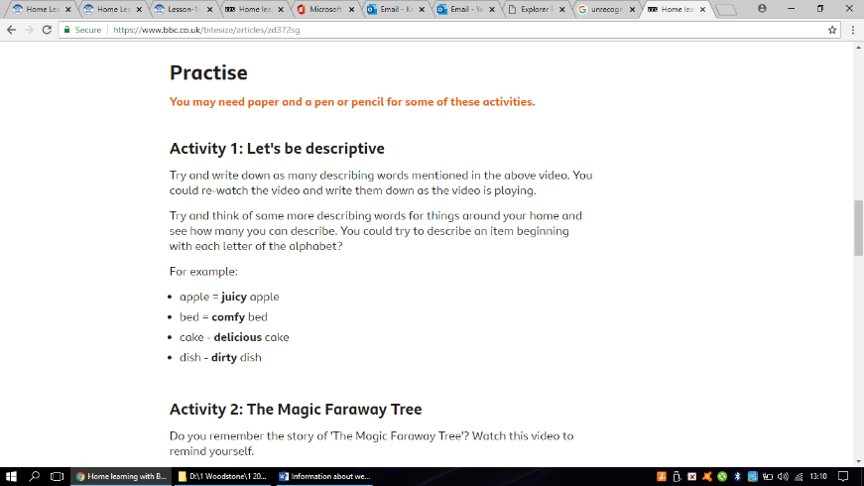

Optional extension: The children then may also wish to complete the other activities or games that are linked to the lesson as displayed in the screenshot below.
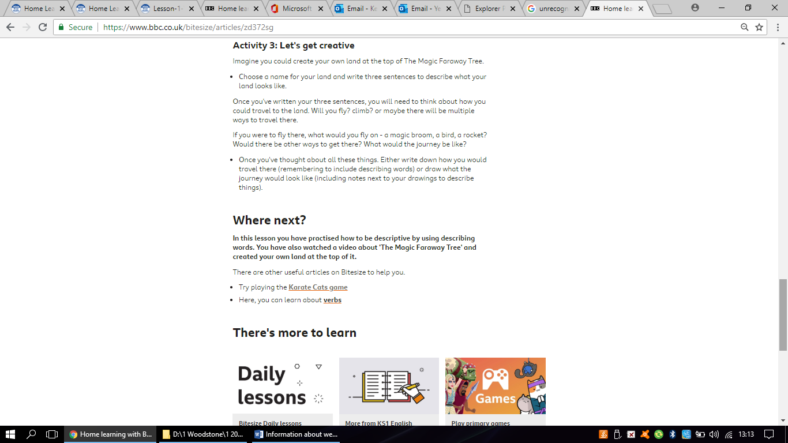

Phonics – Letters and Sounds
Letters and Sounds have designed a series of daily phonics lessons for the summer term using the same phonics programme we follow in school. These lessons will be introduced by celebrities which adds an exciting addition to the lessons. The first lesson will become available on Monday 27th April at 10.30am and following lessons will be released daily at the same time. Therefore, we will work a day behind to allow me watch the video first, enabling me to answer any questions you may have.
Please note, there will be three different lessons available: ‘Learning to blend’ for children working on words such as ‘cat’ and ‘tap’, ‘Reception Summer Term’ for those children working on words such as ‘fish’ and ‘rain’ and ‘Year 1 Summer Term’ which is the lesson I would recommend for most children in Year 1. However, if your child is working slightly behind in phonics, I would recommend the ‘Reception Summer Term’ lessons. Please email me if you are unsure about which lesson your child should watch. I will provide a link to these lessons on the Daily Rainbow Challenge sheet. I have attached more information about these phonics lessons to this email.
Please note, we will not start these lessons until Tuesday 28th April. I will set an alternative activity for Monday’s Phonics Challenge.

I hope you find this information useful.
Please email me if you have any further queries.

K.Barnes

