Recycling

The Big Battery Hunt is still on, a nationwide programme to help educate and inspire young people to recycle more of their used batteries.
Thank you to everyone who has been collecting and saving batteries from going to landfill. Our Eco members Olivia and Annabelle have taken on the task of counting our batteries before they are recycled and to date Woodstone have stopped 3040 batteries going to landfill so far.
Please let our team know if you would like another collecting box as we will continue to offer recycling for batteries at Woodstone.
Our next newsletter will feature energy saving tips. If you think you have any great ideas please email them to gardening@woodstone.leics.sch.uk and we will include them, thank you.
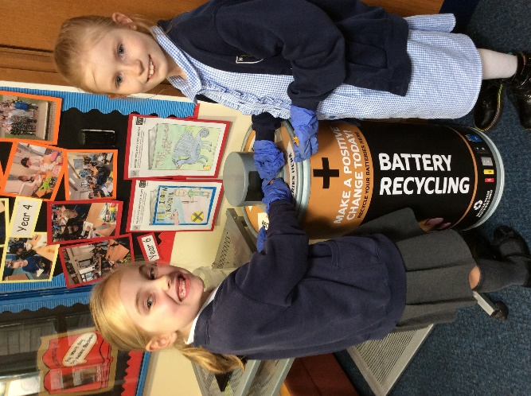
Inkjet Cartridges
Biscuit Wrappers

We Recycle
Batteries

Sweet and chocolate pouches and wrappers
Clothing
etc.

